
BAR CODE MEDICATION ADMINISTRATION (BCMA)
BCMA Backup System (BCBU)
InterSystems Caché Installation Setup
PSB*3*65
Version 3.0
July 2011

Department of Veterans Affairs

Product Development

Revision History
The table below lists changes made since the initial release of this manual. Update an existing manual with the Change Pages document or print out the entire updated manual.

Note: Some pages in the Change Pages document are unchanged, but provided for two-sided copying only. Only changed pages include the patch number and revision date in the page footer.

Date | Revised Pages | Patch Number | Description
07/11 | All | PSB*3*65 | Footers updated; removed HSITES and added Product Development, removed VistA. Renamed instances of CACHE to Caché throughout the document. Updated version to reflect BCMA v3.0 version.
08/03 |  | PSB*2*17 | Original Released Bar Code Medication Administration Backup System (BCBU) InterSystems Caché Workstation Installation Setup Guide.

Table of Contents

Intersystems Caché Installation Setup 1
Caché Configuration Manager 6
Adding a Database 7
Global and Routine Mapping 11
Global Mapping 11
Routine Mapping 12
Copying BCMA Configured CACHÉ.DAT file 14
Removing Read/Archive Properties 15
Telnet Instructions 17
Setting up Telnet and Terminal Users 19
Setting up the BCMA Shortcut 20

Intersystems Caché Installation Setup
This section illustrates step-by-step installation of Caché v5.2, for use with Bar Code Medication Administration Backup System (BCBU) Workstation.

The Caché software is downloaded from any of the VA FTP sites and is located under the CACHE folder with different version under different folders. To start the setup locate the downloaded executable and run it.
Figure 1

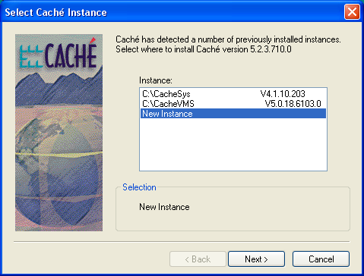
Select New Instance and click Next. Type Caché as the Instance name and click Next as shown in the following screen.

Figure 2
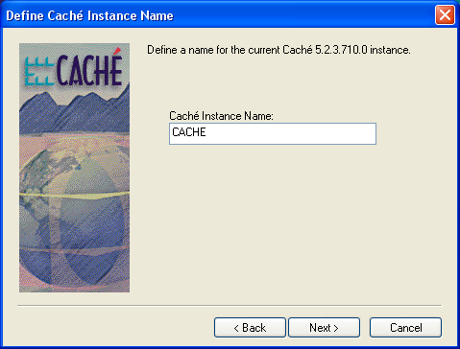

Accept the Standard setup and click Next.
Figure 3
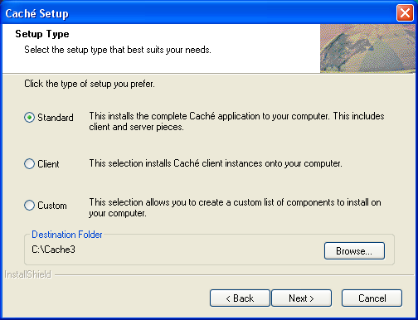

Continue following the instructions and accept the defaults for your system.
Figure 4
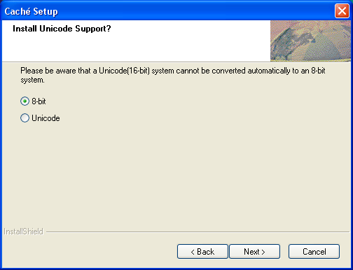
Figure 5
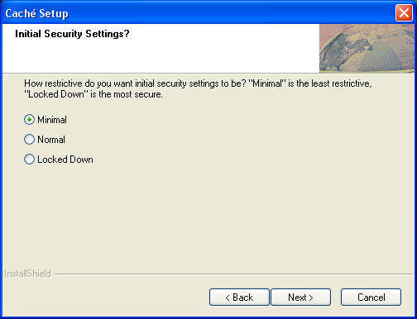

If the following message appears, follow the instructions and enter the licensing information from InterSystems.
Figure 6
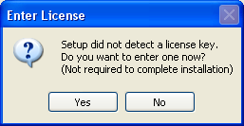
Figure 7
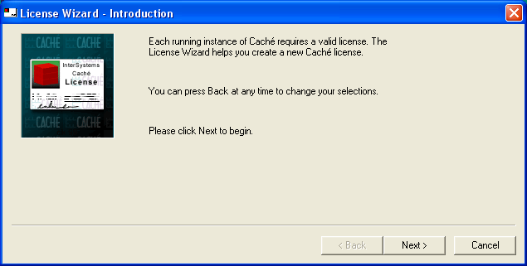

Type your license information as requested in the following screens. Click NEXT to continue.
Figure 8
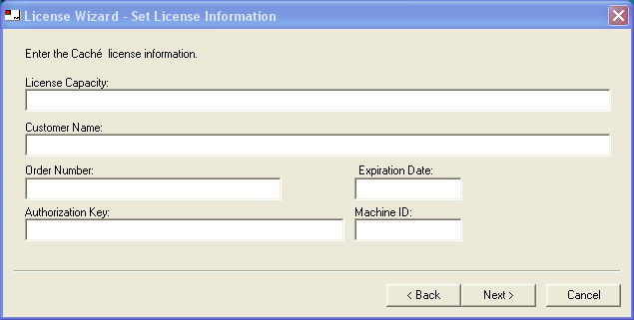

When the licensing information has been entered correctly, the following screen will appear. Click Finish to save the licensing information.
Figure 9
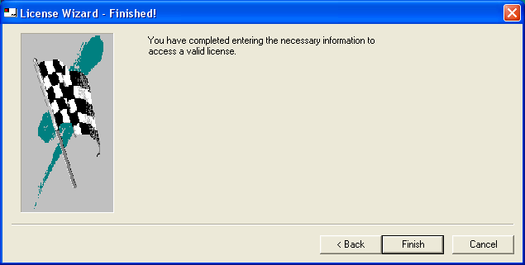

Check the installation options then click Next on the following screen, to complete the installation.
Figure 10
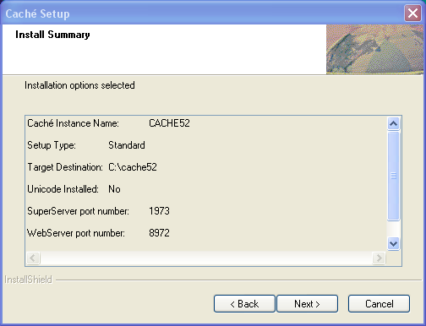

Upon the completion of a successful installation, a "Blue Cube" will appear on the PC toolbar in the lower right hand side of the screen.
Figure 11

Right clicking on the cube will display the menu options for Caché.

Figure 12
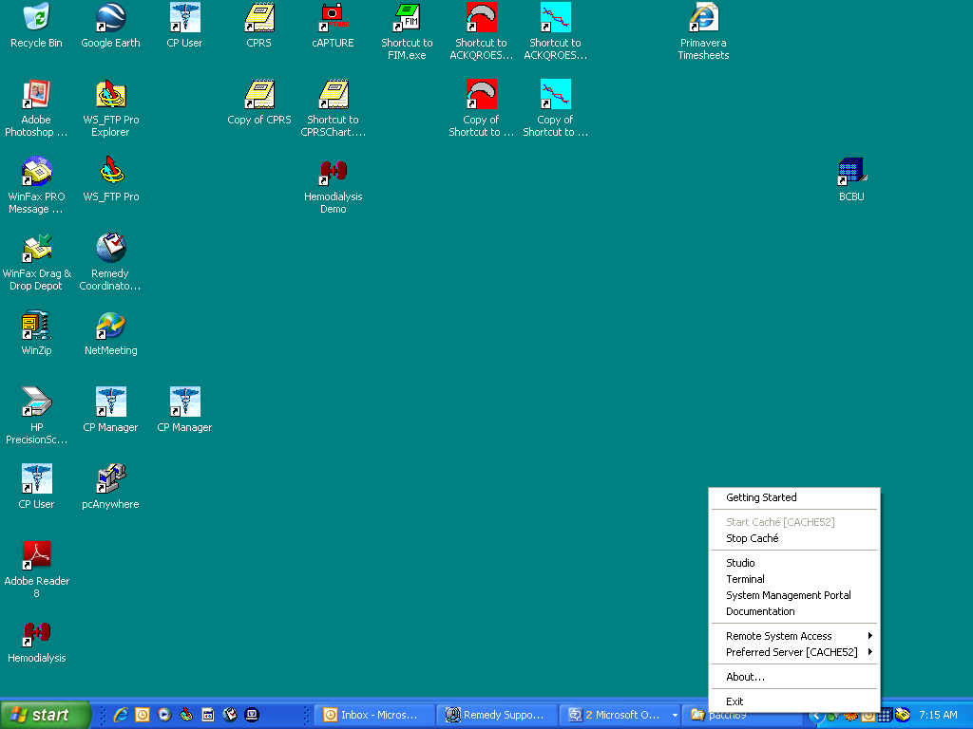

Caché Configuration Manager
Caché must be configured with databases, namespaces and routines by using the System Management Portal located on the Caché cube menu options.
Figure 13
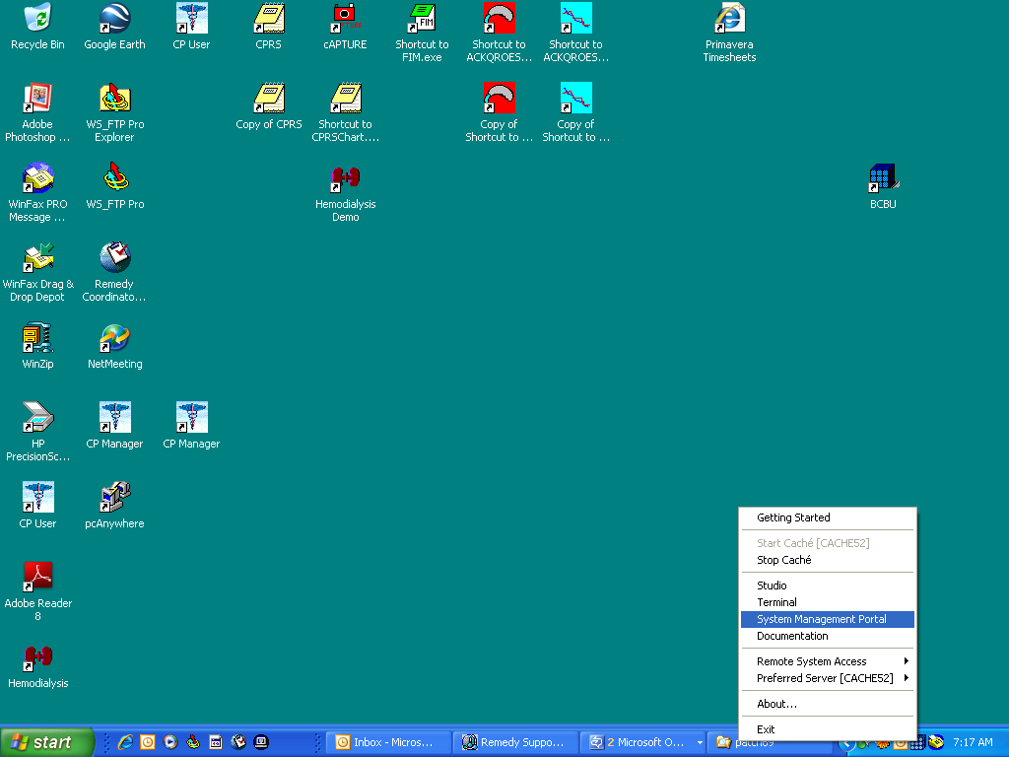

Figure 14

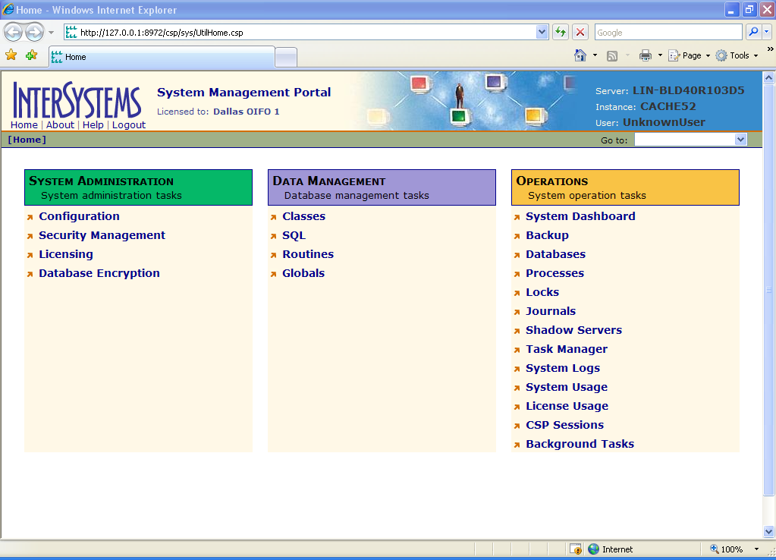

Adding a Database

The first step is to add a Database. After selecting Configuration from the System Administration option, the following screen will appear.
Figure 15
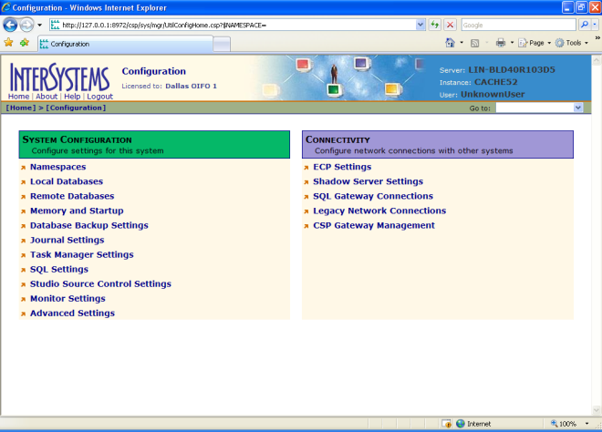

Select the Local Database option and then Create New Database.
.
Figure 16
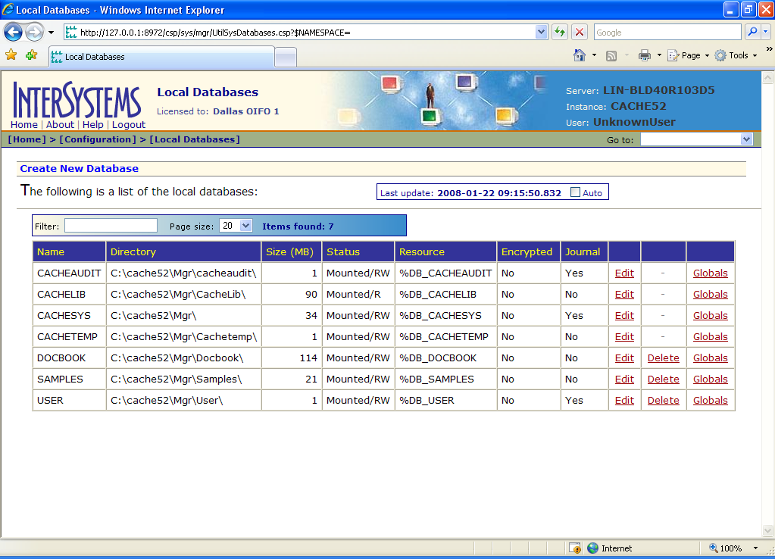

Type VistA as the name of the database and enter C:\BCMABU into the Directory Selected field. Click NEXT to continue.

Figure 17
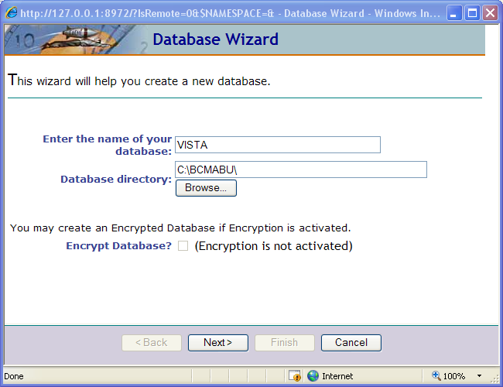

Take default values and click Next to continue.
Figure 18
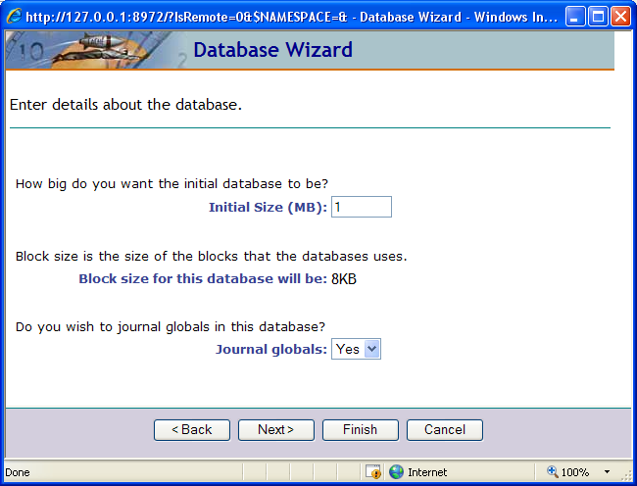
Figure 19
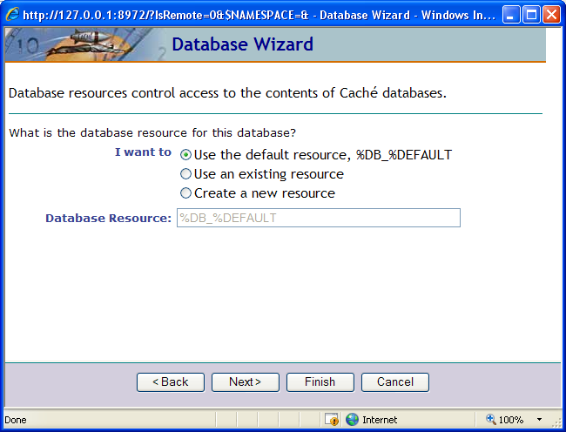

Verify values entered and click FINISH on the following screen.
Figure 20

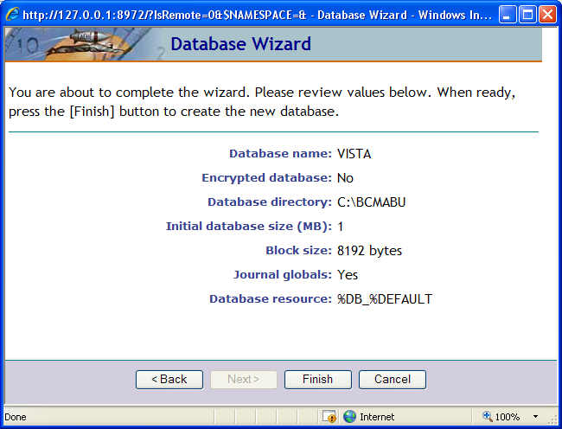

The newly created database should now appear in the list with C:\BCMABU as its directory.

Figure 21
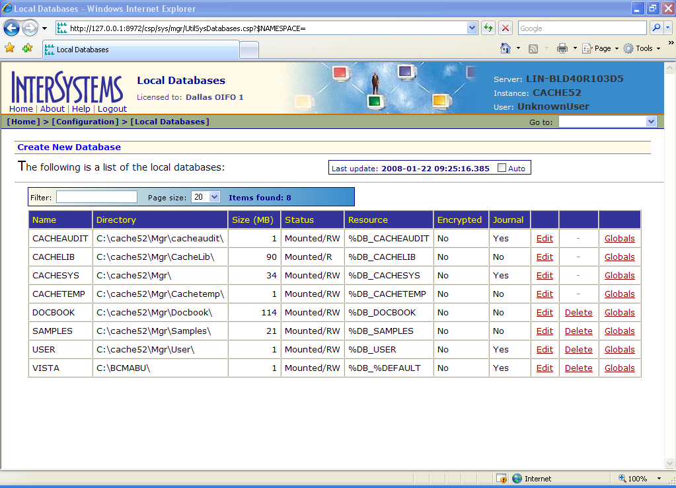
Adding a Namespace

To add the Namespace, return to the Configuration option. Click on the Namespaces then Create New Namespace. The namespace VistA will be created and will be attached to the VistA database.
Figure 22
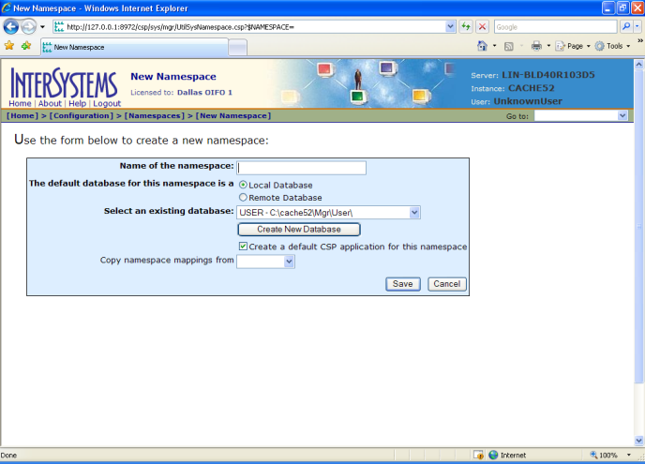

Type VistA as the namespace and select VistA – C\BCMABU\ as the existing database. Click Save.
Figure 23
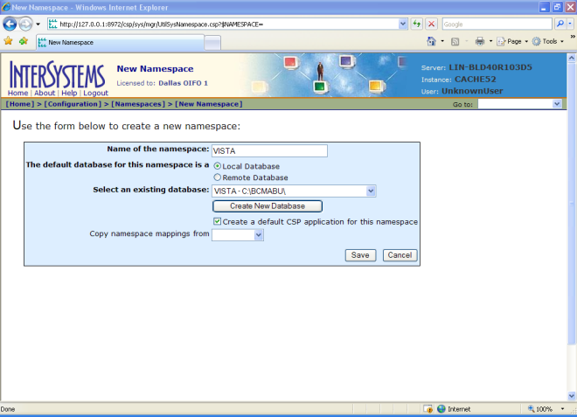

VistA namespace should be seen in the listing of Caché Namespaces.
Figure 24
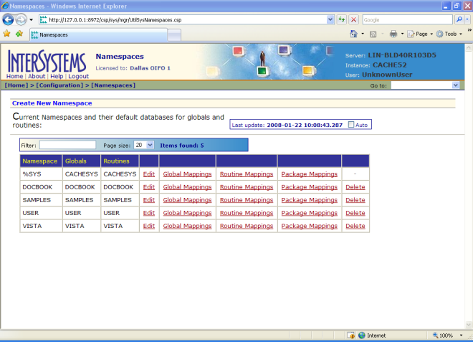

Global and Routine Mapping

Global and Routine Mappings are created under the Configuration / Namespace option by selecting Global Mappings and Routine Mappings for the VistA namespace.

Global Mapping

Click Global Mappings for the VistA namespace. Then click New Global Mapping to create the global mapping definition as shown in the following slides.

Figure 25

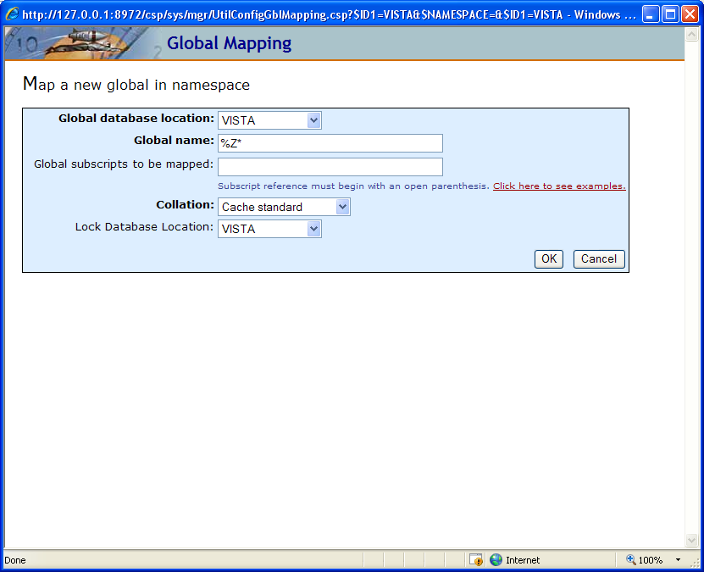

After the fields are filled in as shown, click OK and then click Save Changes.
Figure 26
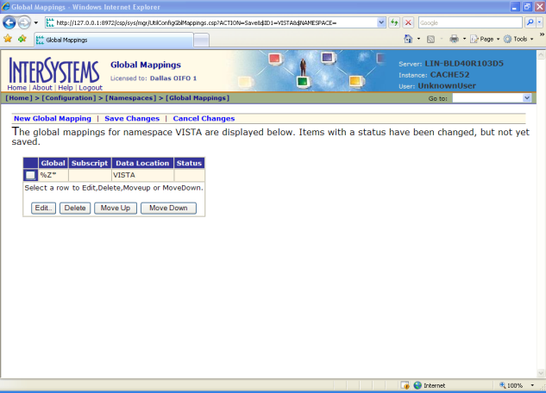

Routine Mapping

Return to the Configuration / Namespace option and select Routine Mapping for the VistA namespace.
Figure 27
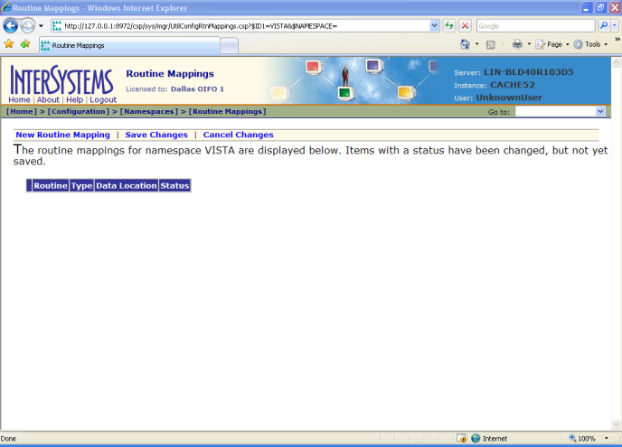

Select New Routine Mapping. Type the first routine name, %DT*, in the space provided and select VistA as the routine database location. Click OK. Repeat this procedure for routine name %RCR, %XU* and %Z*. When complete, your routine mapping should appear as shown in the following screen. Click Save Changes.
Figure 28
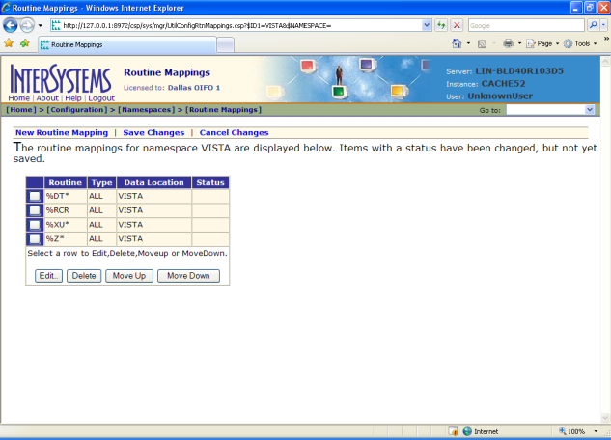

Shut down CACHÉ as shown in the following examples.
Figure 29
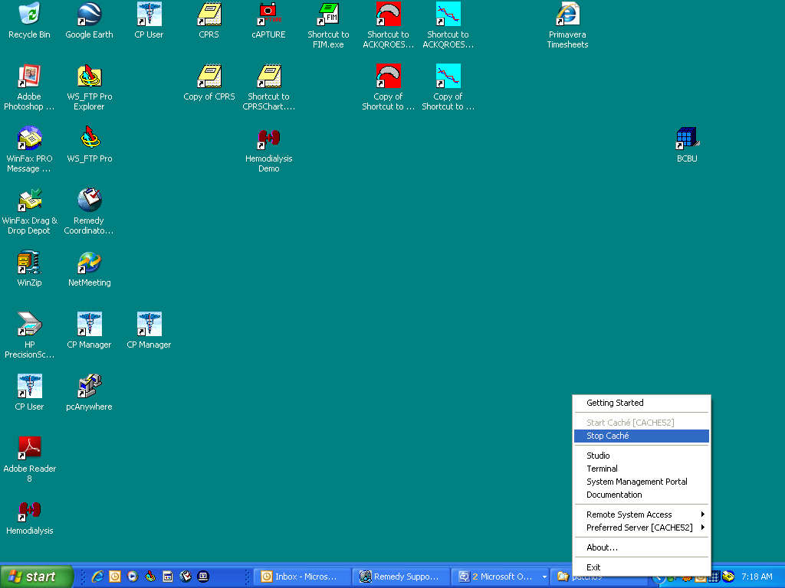

Select Shut Down and click OK.
Figure 30
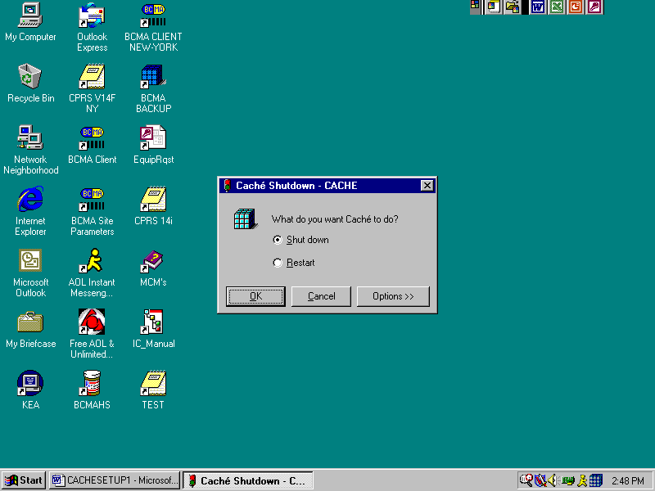

The following screen will appear.
Figure 31
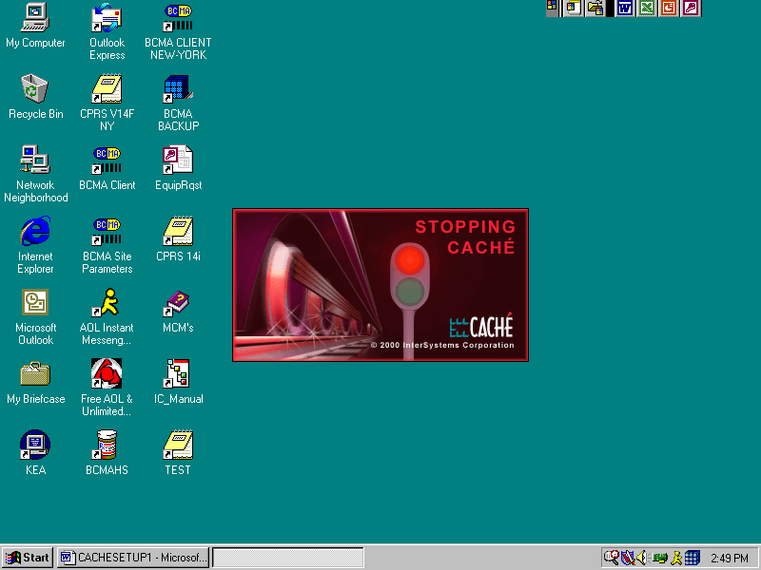

Copying BCMA Configured CACHÉ.DAT file

Locate the CACHÉ.DAT file that you downloaded from our FTP site and copy it to the C:\BCMABU folder.

You may receive a message stating the file is already present and do you want to replace it with the file you are importing. If so, answer YES.
Figure 32
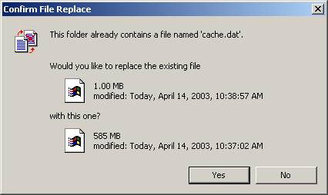

Removing Read/Archive Properties

Using the "Windows Explorer", remove the Read and Archive Properties from the CACHÉ.DAT file. Right click on the icon “CACHÉ.DAT” and select "Properties".
Figure 33
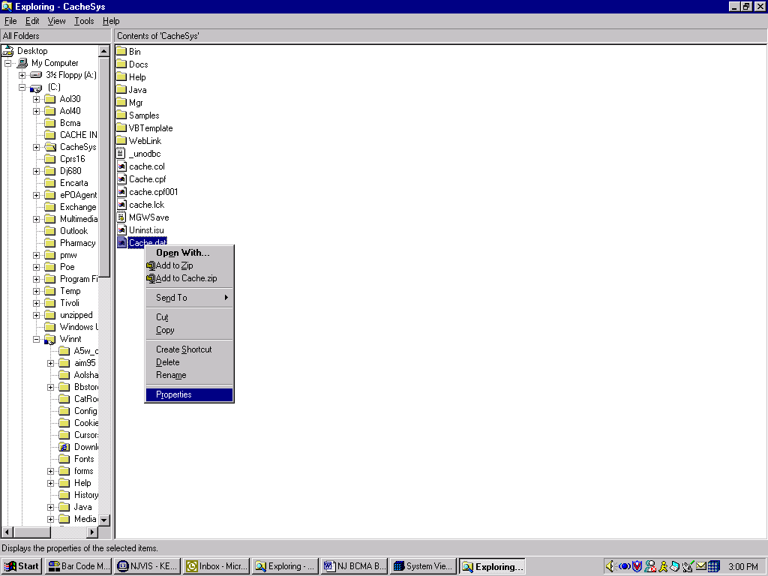

The following screen appears. Click Read-Only. This will deselect these attributes. (Note: This screen shows properties for Windows 2000)
Figure 34
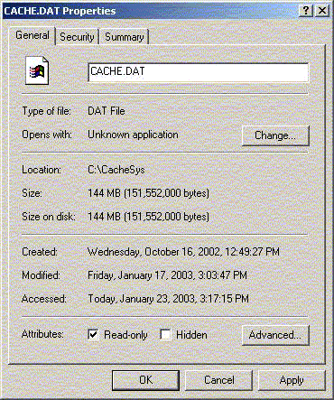

Click the Read-only attribute to deselect it.
Figure 35

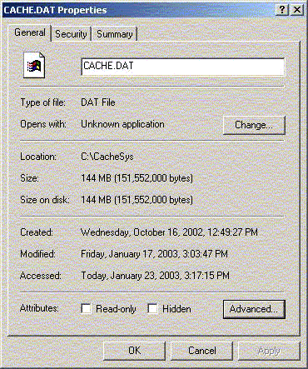
Click OK to close the box and save your changes.

Telnet Instructions
Start Cachè.
Figure 36
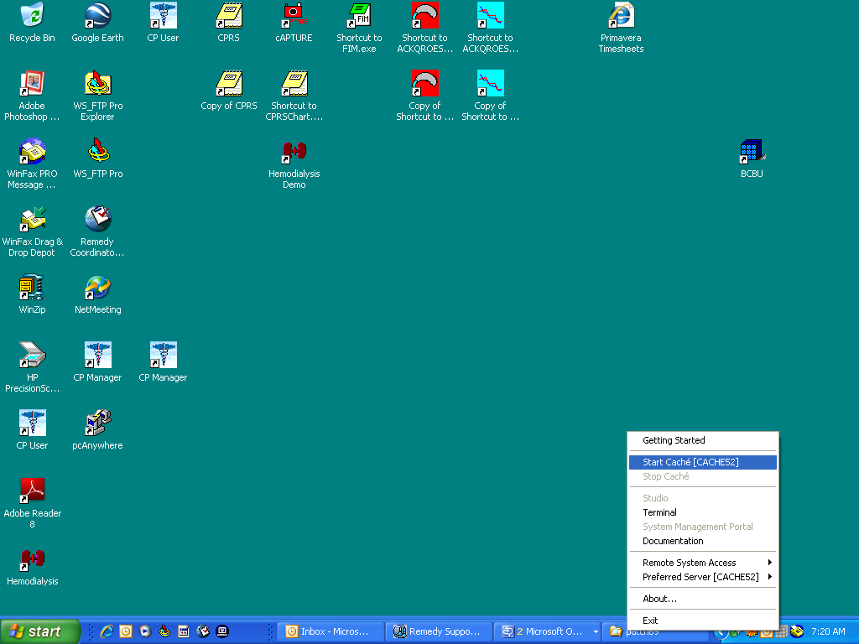
Figure 37
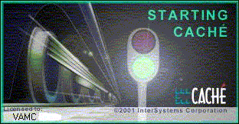

Move the ZSTU routine from the VistA namespace to the %SYS namespace through the System Management Portal. Select Routines under Data Management. On the left side of the screen, select the VistA namespace. Then select Export from the option across the top. Enter a name to save the exported routine as and also enter ZSTU in the search mask. Then click Search. The routine should appear in the list. Select it and click Export. When finished, a message stating it was completed should appear.
Figure 38
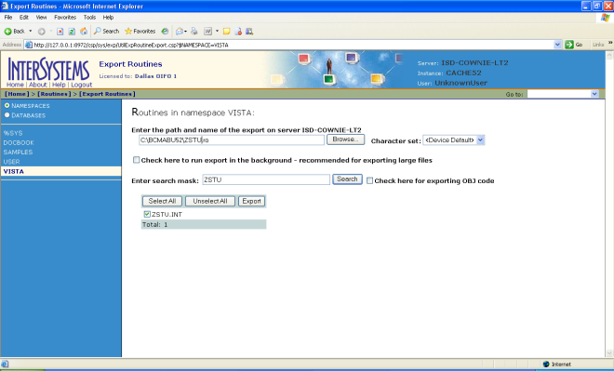

Return to the Routines option and select Import from across the top. Select the %SYS namespace. Browse to the path where you exported the routine. Select the routine and click OK.
Figure 39
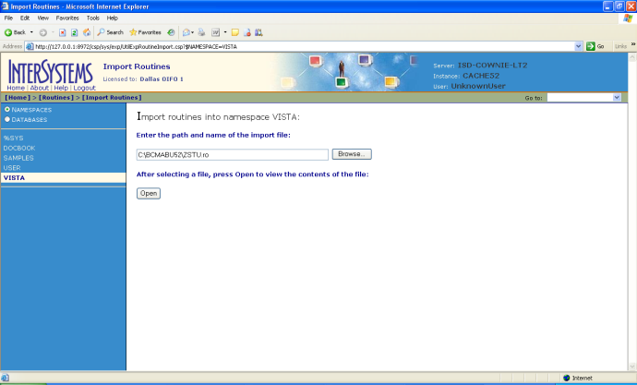

Click Open. The following screen should appear.
Figure 40
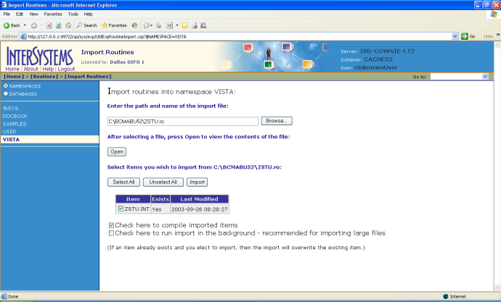

Click Import. The successful completion message should appear as shown in the following screen.
Figure 41
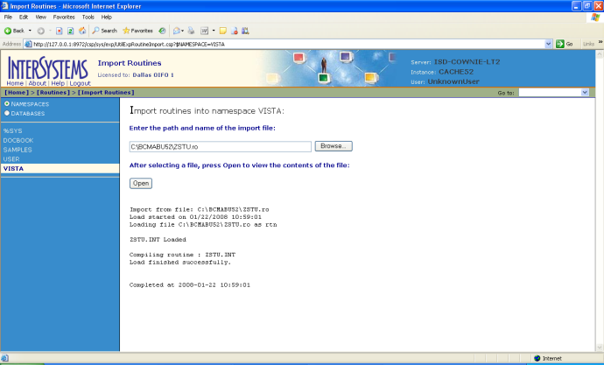

Setting up Telnet and Terminal Users

Using the System Management Portal; set up the Unknown User so the Telnet and Terminal Users may connect to the VistA namespace under the routine ZU. Right click on the blue cube located in the tool tray and go to System Management Portal.
Figure 42

Select Security Management then select Users. The User Accounts will be displayed.
Figure 43

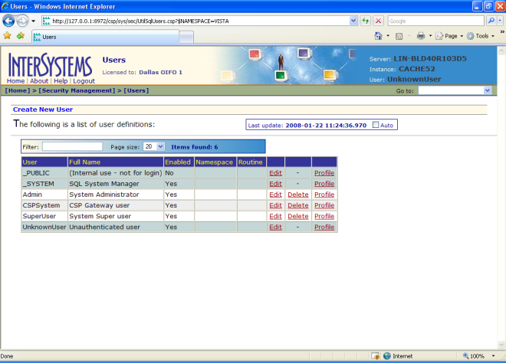

Click Edit for the Unknown User. Select VistA as the Default Namespace and enter ^ZU as the Default Tag^Routine. Click Save then Close.
Figure 44

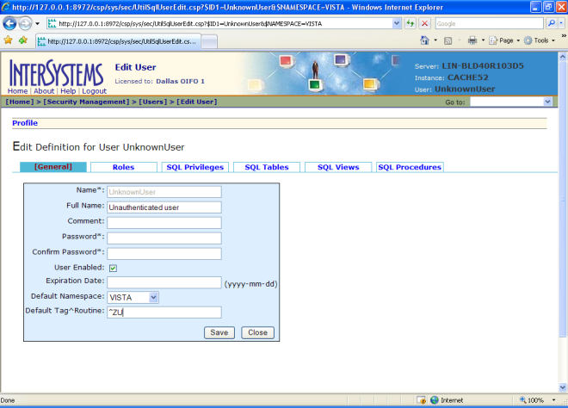

IMPORTANT NOTE: Stop and restart Caché. This will be the BCMA Backup Application. The routine ZSTU start up routine will automatically start up TaskManager.

Verify certain parameters are set for proper operation.

- Under Security Management select Services. Set %Service Telnet Enabled = Yes and Public = Yes.
- Return to Home, select Configuration then Advance Settings. On page 6 make sure the Telnet Port is set according to your site specifications. Default setting is 23.
- Return to Configuration, select Memory and Startup. Make sure the “Start Cache on System Boot” is checked. If not, check it and click Save.

Optional - After this step, ensure you have removed the CACHÉ Configuration cube from the tool tray and startup menu of all users. It will be kept on the Network Administrator profile. Those programmers will be working with the system. All users should have access to the short cut for Telnet.

Setting up the BCMA Shortcut
Right click anywhere on the desktop and select New/Shortcut.

Figure 45

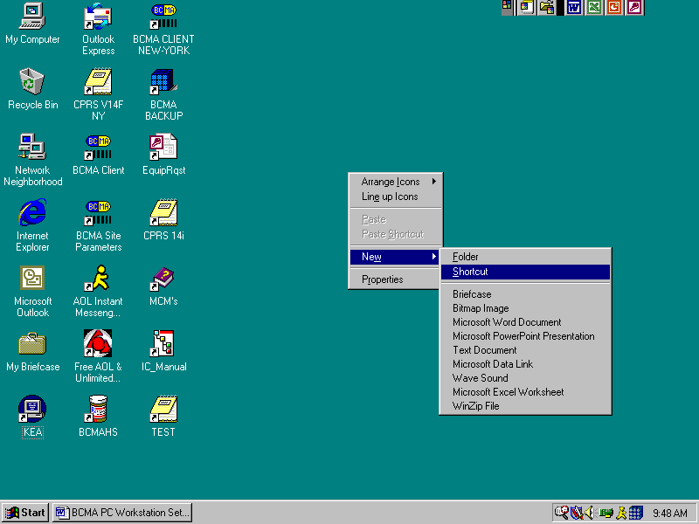

Enter the command line C:\CacheSys\Bin\css.exe CTERMINAL CACHÈ and click Next.
Figure 46

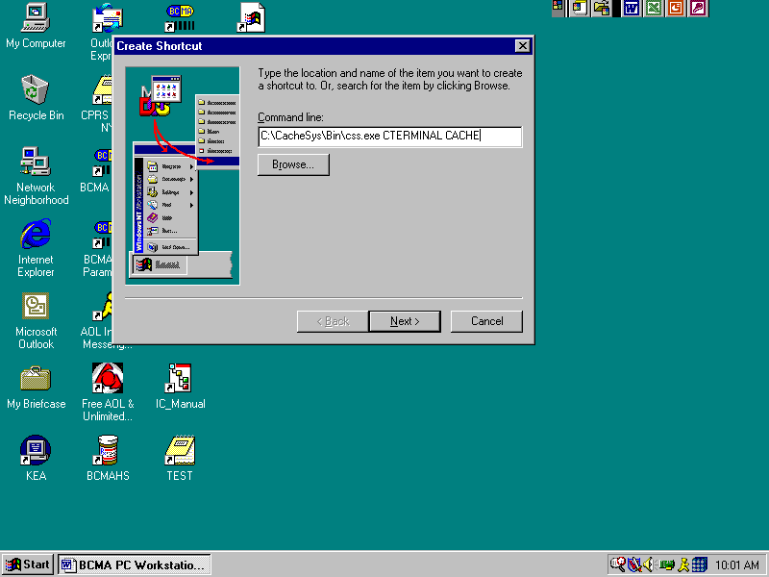
Figure 47
Enter desired shortcut name and click Finish.

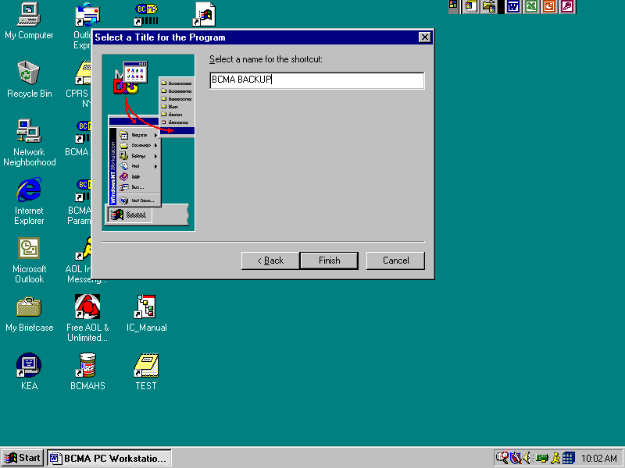

Figure 48
Double-click the BCMA Backup shortcut icon to enter the Backup system on the PC Workstation. Use the appropriate access and verify code to access the system.

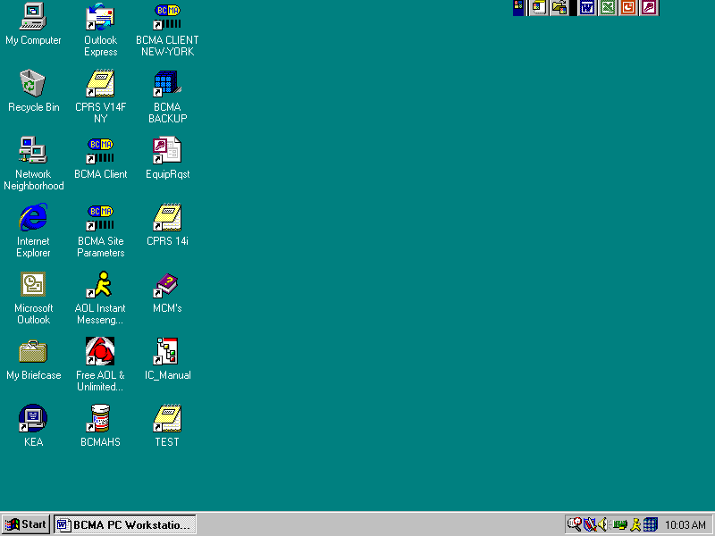

Figure 49

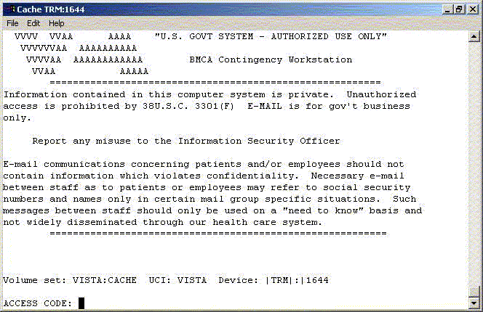

This completes the setup of InterSystems Caché on the BCBU contingency workstation. For information on setting up the package in VistA, please refer to the BCMA Backup System (BCBU) Installation Guide.

